**Assignment -3**

**Python Programming**

|  |  |
| --- | --- |
| Assignment Date | 30 September 2022 |
| Student Name | Kancharla Vengababu |
| Student Roll Number | 1919102066 |
| Maximum Marks | 2 Marks |

**Question:**

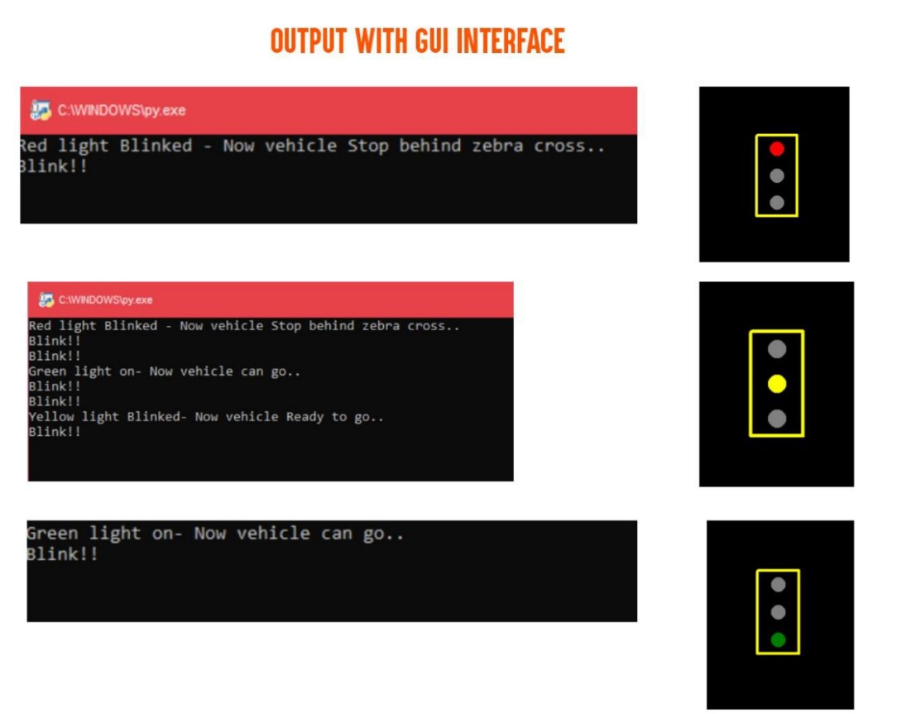1. **Write python code for blinking LED and Traffic lights for Raspberry pi. Only python code is enough, no need to execute in raspberry pi. Note: you are allowed to use web search and complete the assignment**

**Code:**

#Traffic light for raspberry pi simulating in python with GUI

import turtle

import time

wn= turtle.getscreen()

wn.title("Stoplight By kiruthika")

wn.bgcolor("black")

#gui interfrace

pen= turtle.Turtle()

pen.color("Yellow")

pen.width(4)

pen.hideturtle()

pen.penup()

pen.goto(-30, 60)

pen.pendown()

pen.fd(60)

pen.rt(90)

pen.fd(120)

pen.rt(90)

pen.fd(60)

pen.rt(90)

pen.fd(120)

#red light

red_light =turtle.Turtle()

red_light.shape("circle")

red_light.color("grey")

red_light.penup()

red_light.goto(0, 40)

#Yellow light

yellow_light =turtle.Turtle()

yellow_light.shape("circle")

yellow_light.color("grey")

yellow_light.penup()

yellow_light.goto(0, 0)

#Green light

green_light =turtle.Turtle()

green_light.shape("circle")

green_light.color("grey")

green_light.penup()

green_light.goto(0, -40)

while True:

yellow_light.color("grey")

red_light.color("red")

print("Red light Blinked - Now vehicle Stop behind zebra cross..")

print("Blink!!")

time.sleep(2)

print("Blink!!")

red_light.color("grey")

green_light.color("green")

print("Green light on- Now vehicle can go..")

print("Blink!!")

time.sleep(3)

print("Blink!!")

green_light.color("grey")

yellow_light.color("yellow")

print("Yellow light Blinked- Now vehicle Ready to go..")

print("Blink!!")

time.sleep(1) print("Blink!!")

wn.mainloop()

Output Screenshot:

